Standard Subsystems Library (SSL)
Introduction to work with files
It should be understood that working with files from the an information system may mean different scenarios:
- Opening a file from the file system, changing, saving
- Storing file data in the information system (or in separate storages), including attaching files to system objects (for example, a photograph showing defective products must be attached to a document on acceptance of goods)
- Working with files stored in the information system: viewing, versioning, sequential changing (for example, while one user edits a file, others cannot edit it)
SSL mechanisms provide mechanisms that process data and other scenarios, but these mechanisms can be supplied in different subsystems.
For example, when it comes to working with files in the file system, such functions are provided by FileSystem common modules related to the "Core" subsystem.
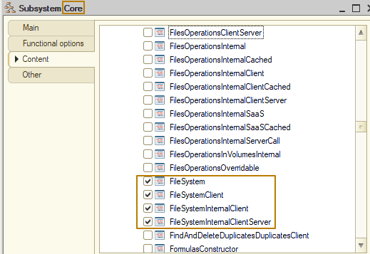
Working with files stored in the information system or in separate storages, as well as their application to data objects and other related functions are provided by a separate subsystem "FilesOperations".
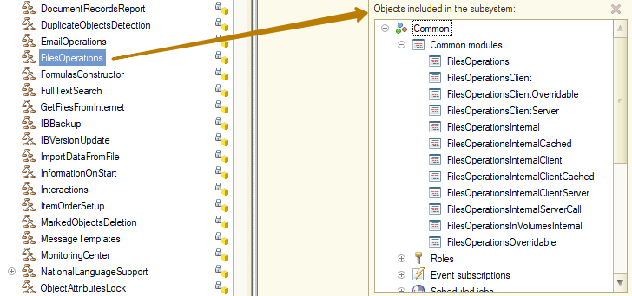
Thus, the configuration developer can decide to integrate certain subsystems into the configuration at the design stage, when the system requirements are known.
In this lesson we will get acquainted with some useful SSL mechanisms for working with files. This will give you an understanding of the capabilities available in the library and may save time on development in the future.
File system
We have already worked with files from the file system when worked with print forms, as well as processing for loading data from an Excel file. As part of those tasks, we learned how to provide the user with a file selection, and then interact with this file, having a full path to it. Let's look at some useful methods from this subsystem that can simplify working with files in such operations as selecting a file/files and then placing its binary data in temporary storage, opening a directory in Explorer, opening a URL in the application assigned by default to this function in the system, and more.
Let's start by creating a new document "Inventory recount", which we will work with in the current lesson. I add the following details to the document: "Warehouse", "EmployeeResponsible", "Comment" and the "Goods" tabular section with the details "Product", "Quantity", "QuantityFact". I rename the "Sales" subsystem created earlier to "Training" and include a new document in this subsystem.
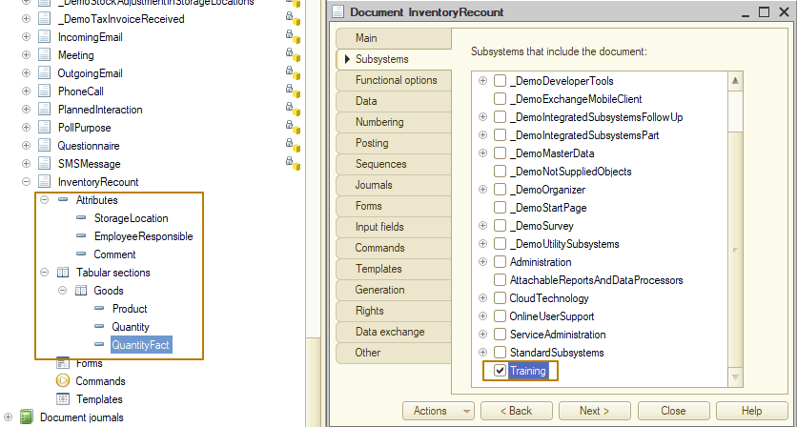
Next, I create a document form:
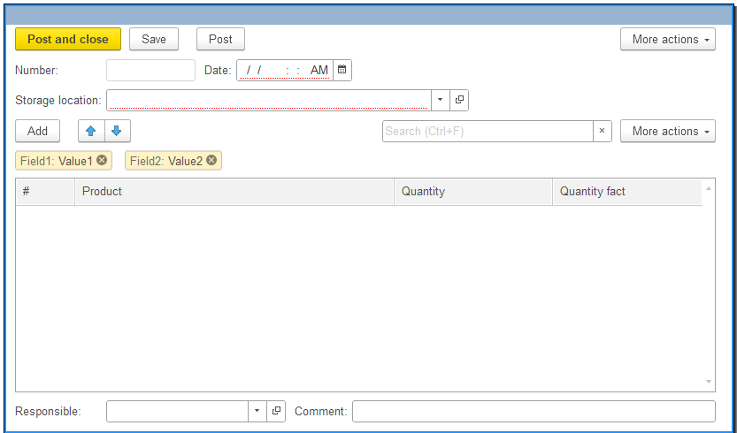
First of all, I want to demonstrate the implementation of the function of providing the user with a file selection using a method from the FileSystemClient common module. Imagine that the result of the recount of goods in the warehouse was entered into an Excel file in the warehouse and sent to the office, where its data needs to be loaded into the system.
I create a "Import data from file" command with a client handler, place it on the form command bar:
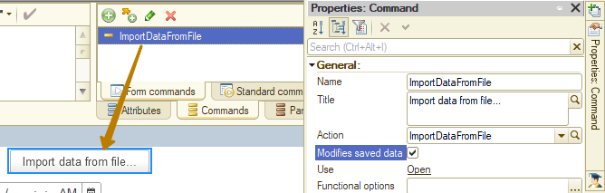
Now in the command handler code, I must call the ImportFile_() procedure from the FileSystemClient common module, to which I need to pass an object of the CallbackDescription type indicating the procedure that should be called upon completion of the file selection process, and, if necessary, I can also pass the file filter parameters, which can be obtained by calling the FileSystemClient.FileImportParameters function:
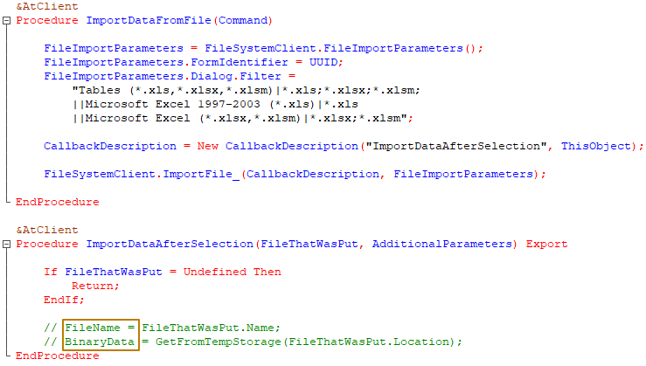
One of the big advantages of the library method is that it handles work in a web client, where some browsers require an extension for working with files. It would take extra time to independently describe the work of checking the current client type and handling the connection or refusal to connect a file extension, and you would still have to implement your own public method for selecting a file, since providing the user with a file selection is a fairly common scenario and there is no point in describing the entire code for each such call. As a result, the developer will still end up implementing his own analog of the file system modules.
Also, the FileSystem modules handle situations when the file selected by the user is busy or missing, which is also useful:
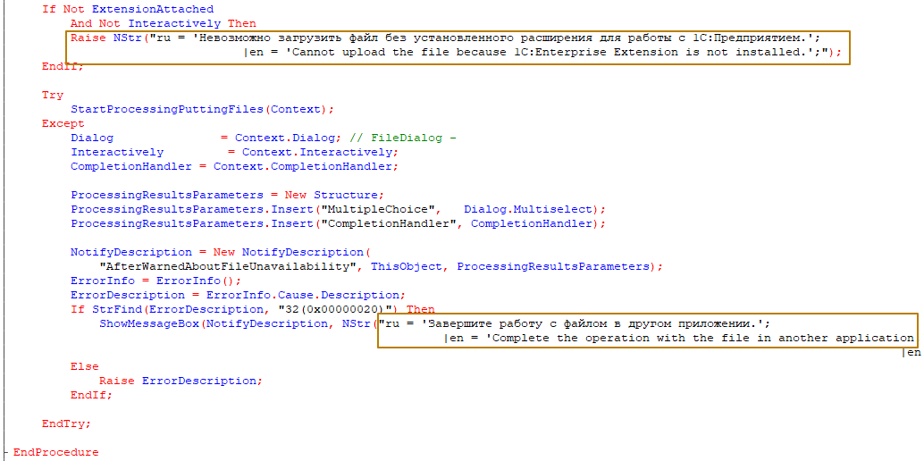
Now let's look at the procedures for opening a URL, opening a directory in Explorer, and opening a file. Let's imagine that we received a request to add to our "Inventory recount" document an attribute for storing the path to the file with the recalculation act and an attribute for storing an Internet link to the same file, for example, located in cloud storage. For ease of use, we should add a switch with two options to the form:
- "File full name". When a user selects this option, we should display an input field for the FileFullName attribute with the choice and open buttons, as well as the "show in Explorer" button to the right of the field.
- "File URL". When a user selects this option, you should display an input field for the FileURL attribute with an open button.
When a user clicks the open buttons, you should open the file or follow the link, depending on which field the button was clicked in. Let's start implementing this task, and I will deliberately not dwell on the details of the implementation of everything that does not concern working with the library subsystem.
So, I created the document attributes, put them on the form in the page group. I also created the "FileType" form attribute, which I added to the form as radio buttons and with which I will switch between pages with the "FileFullName" and "FileURL" fields. For the action of showing the file in the explorer, I created the corresponding command and added it to the right of the "FileFullName" field.
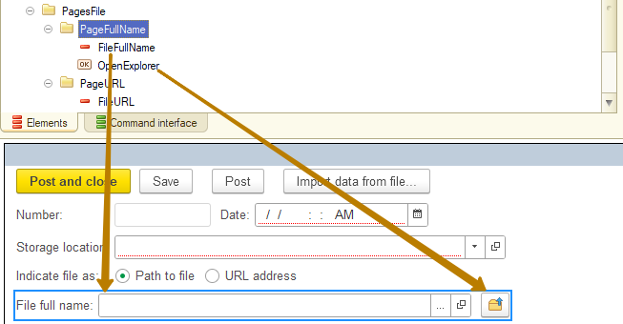
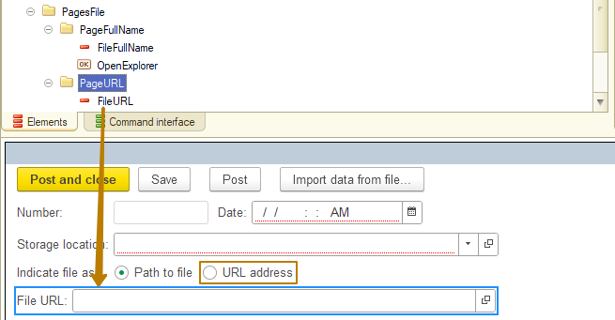
Now in the handler of the open button of the "FileFullName" field, I must check that the field value is filled in, and then call the OpenFile procedure from the FileSystemClient common module or report an error if the field is not filled in. The same logic should be for the "Show in Explorer" command:
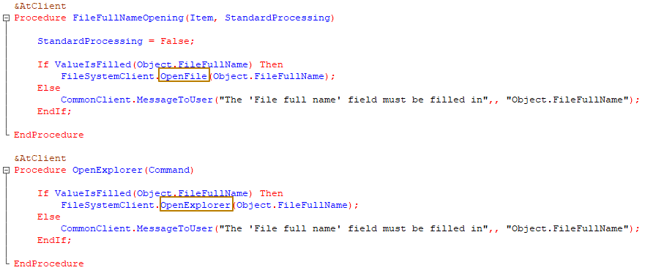
Please note that to display a message to the user I use the CommonClient.MessageToUser() method, which uses the MessageToUser type object, which I have already introduced you to earlier. The MessageToUser() method can accept a Cancel parameter in order to set it to True when called from built-in handlers that have such a parameter. For calling from the server, the server module has exactly the same method: Common.MessageToUser().
The code for handling the button for opening the "FileURL" field is practically no different, it calls the OpenURL method.
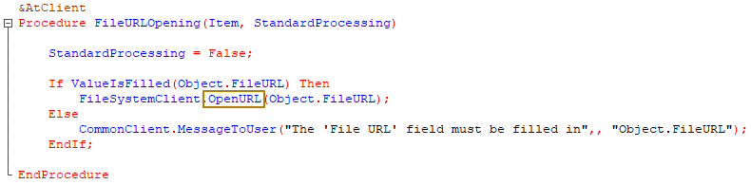
Note: Please note that the OpenURL method works not only for public links that can be opened in a web browser, but also for other links, including links to chats in instant messengers, links to send an email, navigation links to objects in the 1C system, a link to 1C help, and some others. In this case, the link will be opened in accordance with the correspondences between applications and protocols specified in the system.
I check the operation of the buttons and the switch:
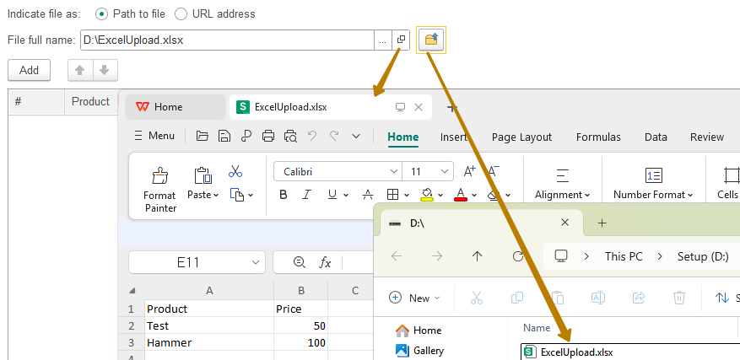
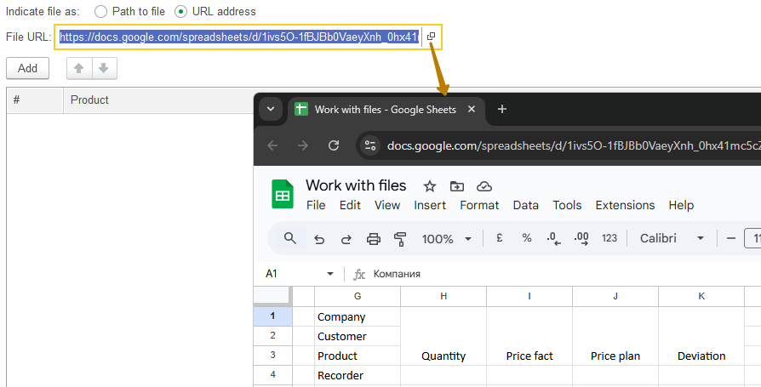
The program checks links for correctness by the beginning of the line using the IsAllowedRef() function. Therefore, if I remove the initial part from the path and try to open such a link, the program will return an error:
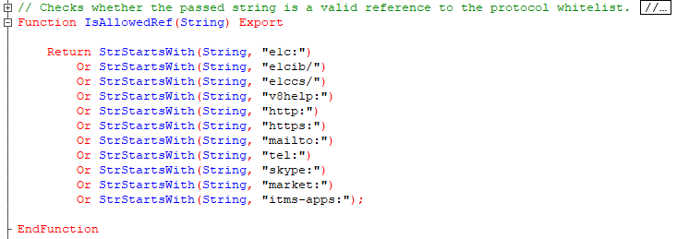
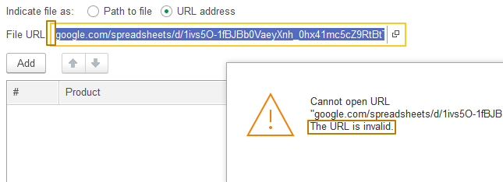
The server common module FileSystem does not contain many public methods, the main part is related to working with temporary files or directories:
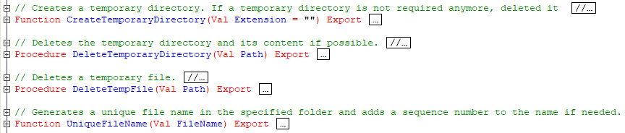
I do not see the point in analyzing them in detail, you can guess their purpose by their names or open the common module and read the description of these methods.
Files operations
In the previous step, I demonstrated a simplified version with storing the file path in the document attribute. In practice, files that should be attached to objects in the information base are stored as attached files. To implement this approach, as well as to store information about files (and in some cases to store the files themselves in the information base) and other operations with files, the SSL has the "Files operations" subsystem.
This is what an object looks like for which the ability to attach files is enabled:
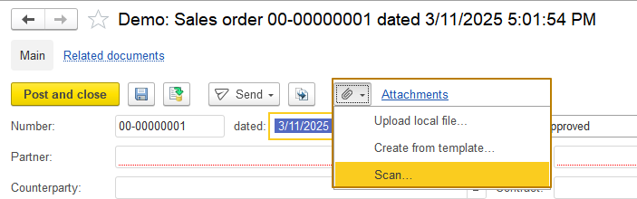
The mechanism of attached files provides the ability to store files for objects of the information base in three ways:
- For each object acting as the "owner" of files, it is necessary to create a separate catalog "<ObjectName>AttachedFiles", for example, for the document "InventoryRecount" the catalog will have the name "InventoryRecountAttachedFiles". This option is used when the access rights to the objects-owners of files differ from each other.
- For several objects-owners of files, a common catalog is created for storing attached files. It is used in cases when there are few file owners (no more than 10), and the access rights to them completely coincide and they are not planned to be changed in the future.
- All files are stored in the Files catalog already included in the FilesOperations subsystem. This method is usually applicable to simple configurations, where the division of access rights is as simple as possible.
Usually, the first method is the most suitable for most configurations, so we will analyze it in our example. However, I must warn you that file versioning is only performed for files stored in the "Files" catalog, so sometimes the methods are combined even within one configuration.. For the "<OwnerName>AttachedFiles" catalogs, there will always be only one version of the file - the latest one.
I want to connect my new document "InventoryRecount" to the FilesOperations subsystem, for this I need to do the following:
- Create a catalog for storing attached files, for this purpose there is a directory _DemoProjectsAttachedFiles in the demo configuration, which can be copied, and then the necessary changes can be made to it. The name of the catalog should be "InventoryRecountAttachedFiles", and the synonym should be "Attached files (Inventory recount)".
Important: Do not forget to remove the access rights for interactive deletion of the new object from the FullAccess role!
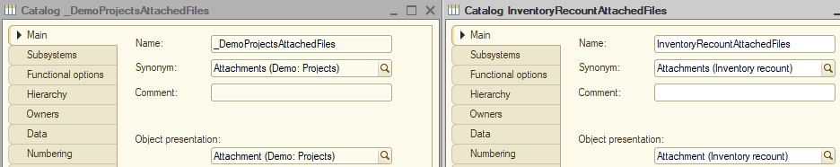
- Set the link to the "InventoryRecount" document as the "FileOwner" attribute type of the catalog
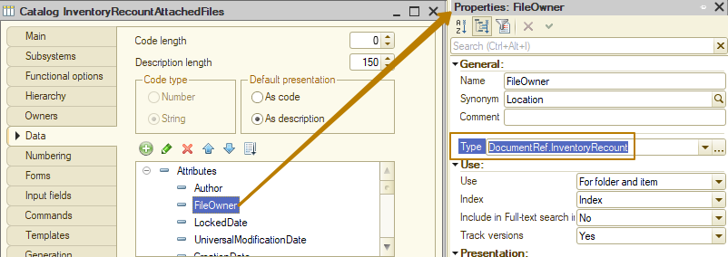
- Decide on the possibility of creating groups in the lists of attached files. To enable the creation of folders, you must enable the "Hierarchical catalog" property for the catalog, set the hierarchy type to "Folder and item hierarchy". Change the value of the Use property to "For folder and item" for the attributes Author, FileOwner, UniversalModificationDate, CreationDate, ChangedBy, PictureIndex, LongDesc. In my case, the catalog was already hierarchical, so if you do not need to create groups in attached files, and the catalog is already hierarchical (because the copied catalog was hierarchical), then disable this property, otherwise you can skip this item.
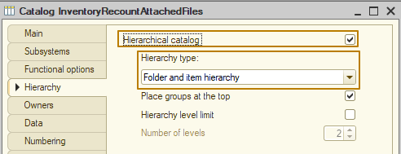
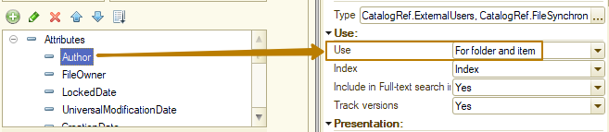
- If the catalog stores attached files that contain service information and should be hidden from users, then you need to add the "Service" attribute of the Boolean type. Otherwise, skip this step;
- Include the catalog created in step 1 (InventoryRecountAttachedFiles) in the defined types "AttachedFile" (links) and "AttachedFileObject" (objects).
Note: To meet this requirement, I had to enable the ability to change these objects in the support options of the configuration.
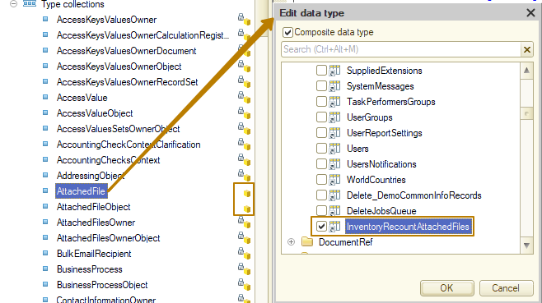
- Include the catalog created in step 1 in the InfobaseUpdate exchange plan.
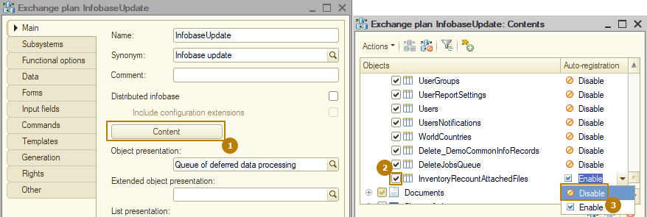
- Create* event subscriptions, including the catalog with files created in step 1 in the "Source" property types of one of them, in my case it is CatalogManager.InventoryRecountAttachedFiles, and object-owner of the files in the types of another one (in case object-owner of a document), in my case it is DocumentObject.InventoryRecount:
Subscription | Event | Handler
DetermineAttachedFileForm | FormGetProcessing | FilesOperationsClientServer.DetermineAttachedFileForm
SetDeletionMarkForAttachedDocumentFiles | BeforeWrite | FilesOperations.SetDeletionMarkForAttachedDocumentFiles
See examples of subscriptions in the demo configuration: "_DemoDetermineAttachedFileForm" and "_DemoSetDeletionMarkForAttachedDocumentFiles".
*If a new object is connected when modifying a standard solution, the specified event subscriptions may be present in the configuration.
I will not create new event subscriptions, but will use the existing ones in the demo database:
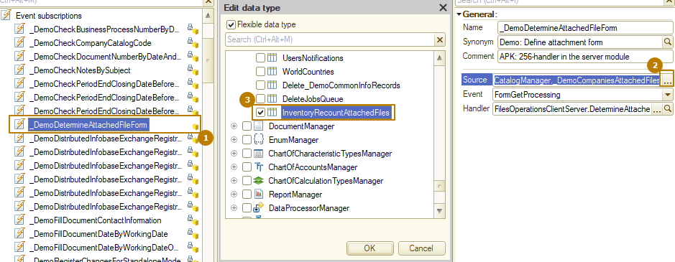
8) Include a link to an object with attached files (in my case, this is DocumentRef.InventoryRecount" in the list of types of the defined type "AttachedFilesOwner".
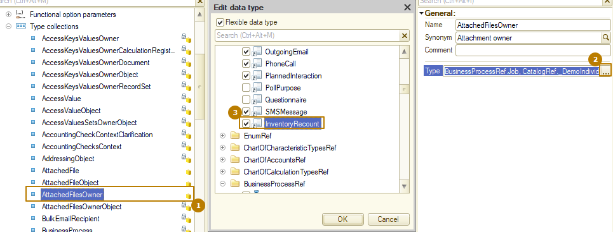
9) If the object is not a document, add its type (object, not link) to the list of types of the defined type "AttachedFilesOwnerObject".
This requirement is not relevant for me, since my file owner is a document.
After completing the above steps, I delete the attributes,, commands and form elements added to specify the file paths and update the DB configuration to check the operation of the attached file mechanism.
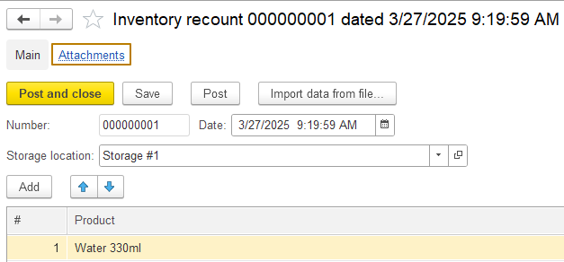
As you can see, a hyperlink to the transition to the attachments has appeared in the document. Let's see what the attachment form looks like:
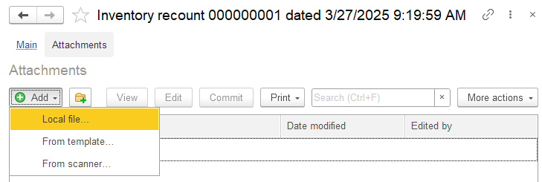
As you can see, there are buttons for adding a file by the specified path, from a template and from a scanner. There are also buttons for viewing, editing, commiting and printing. More buttons can be found in the "More actions" submenu:
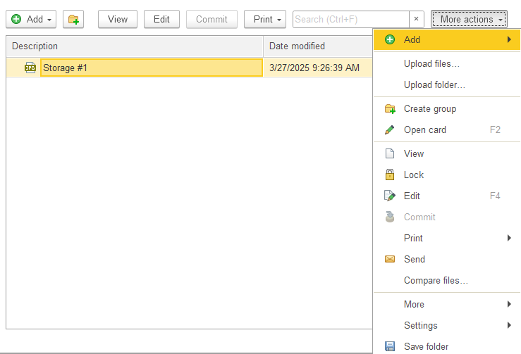
Let me attach an image file from my computer to demonstrate what an attached file looks like. I click "Add local file", select an image file:
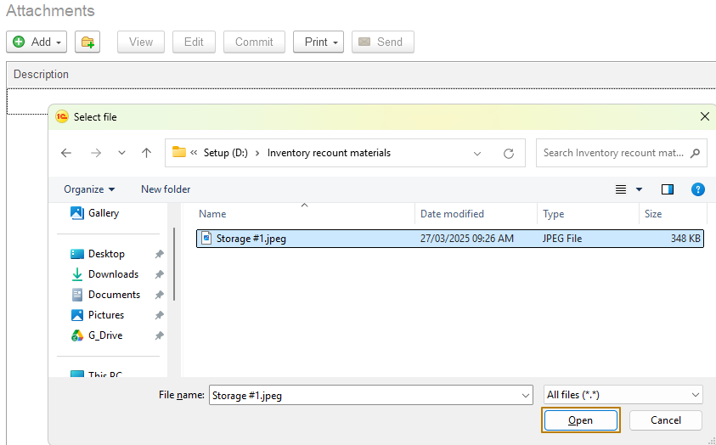
And I see that a row with a file has appeared in the list, and to the left of the name there is even an icon with the file extension (jpg):
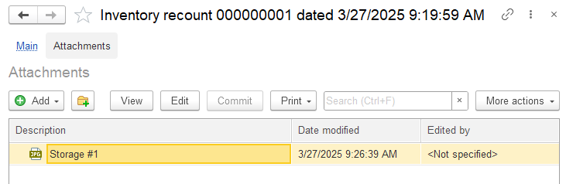
Let's check what happens if I double-click on the row with the file (or press the Enter button while the file is selected):
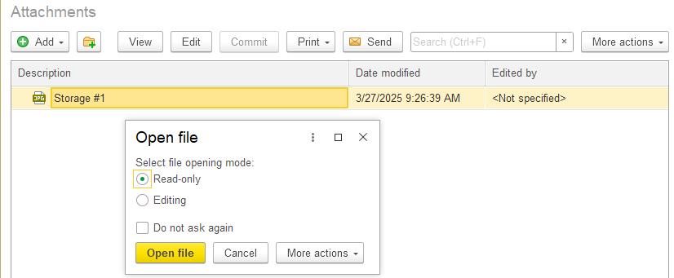
The "Open file" form opens with a choice of two options "Read-only" and "Editing" and the "Do not ask again" flag to remember the selected option for the current user. In fact, the first opening option (read-only) is the equivalent of pressing the "View" button on the file command panel, and the second option (editing) is the equivalent of pressing the "Edit" button. Let's first open the file for viewing:
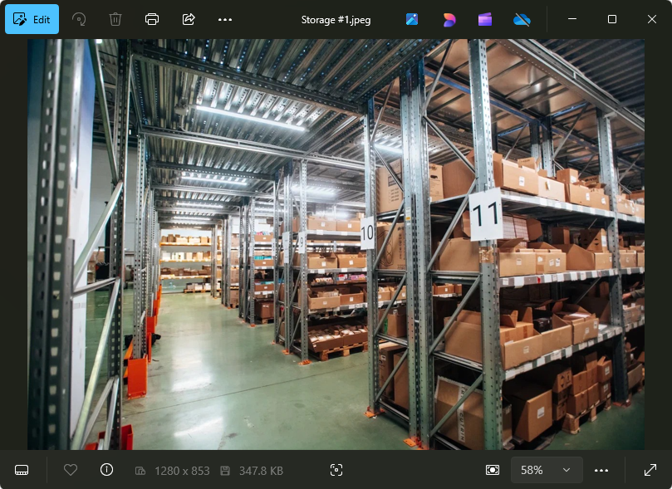
The file opens in the program associated in the system with the .jpg file extension, we are already familiar with this behavior from the previous section "FileSystem". Now I press the "Edit" button:
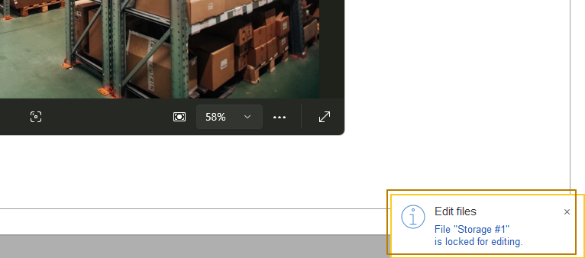
A user notification pops up that the file is locked for editing, the file is opened in the associated system application in the same way, and the text in the file list turns green:
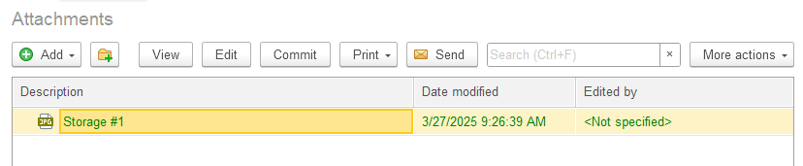
Of course, the example with the image is not the best for demonstrating the sequential change of shared files, but this is not so important, the main thing is that you understand the purpose - at one time only one user can work with the file in the editing mode, the rest can view the latest version of the file at the time of opening (which will be relevant until the user who started the editing process places their changes in the file using the "Finish" button or cancels editing).
Let me click the "Finish" button:
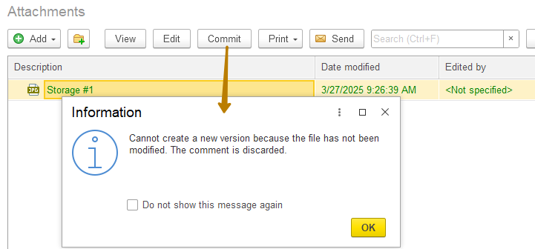
A window appeared stating that the file has not been changed, so a new version of the file has not been created. After clicking the "OK" button in this window, the file will be unlocked for editing, and the text in the line with it in the list will return to its normal color.
Now let's repeat the same process on the Excel file to actually edit the file. I add an Excel file with two lines:
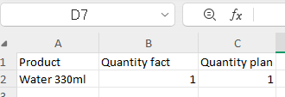
I click the "Edit" button and make changes to the opened file:
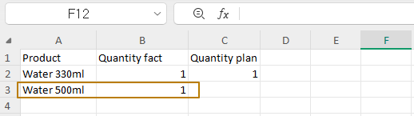
I close the file with saving and press the "Commit" button. This time there was no warning window, and the file modification date in the list changed to the current one:
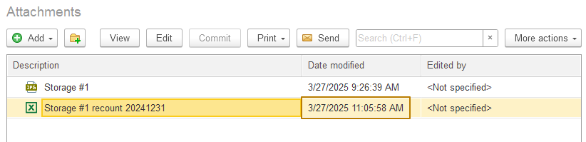
Now let's move on to the file card from the file subsystem. To do this, I can press the F2 button or open the "More actions" submenu and press the "Open card" button:
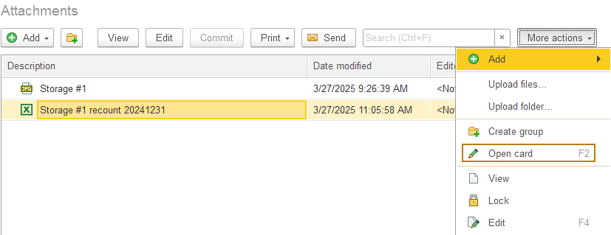
This is what the file card looks like for a file stored in its own catalog of attached files:
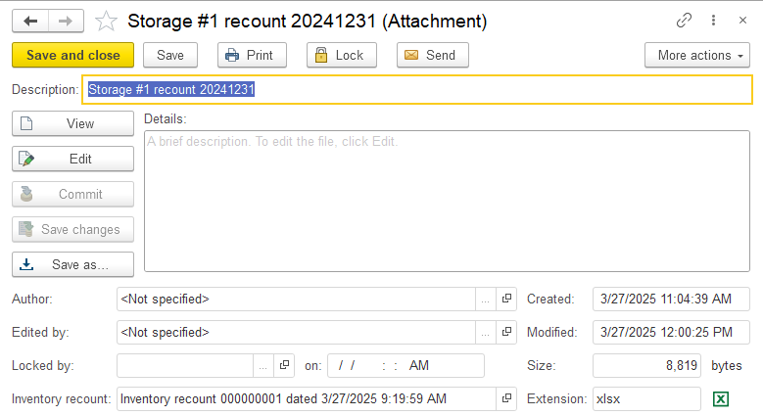
If I now open the file from the program, it will be the latest version with my changes. In the "More actions" submenu there is the "Undo edits" button to cancel editing, which cancels the file lock, however, if the file has been changed and the you press "Undo edits", then when you try to open it for viewing, the program warns that now the local copy of the file differs from the saved file and offers to open the file from the local copy (which contains all the changes made by the user who locked the file) or from the application (the latest "official" version according to the program information)
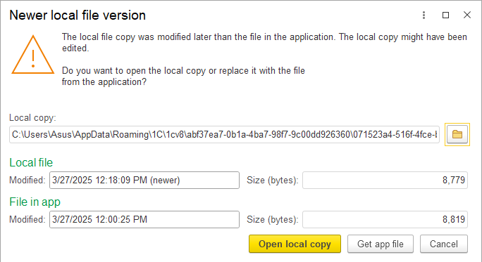
The "Save changes" button updates the version of the file, but does not unlock it, i.e. it remains locked by the user. There is also a button to lock the file without opening it, so that no one can edit the file before it is "released" (unlocked):
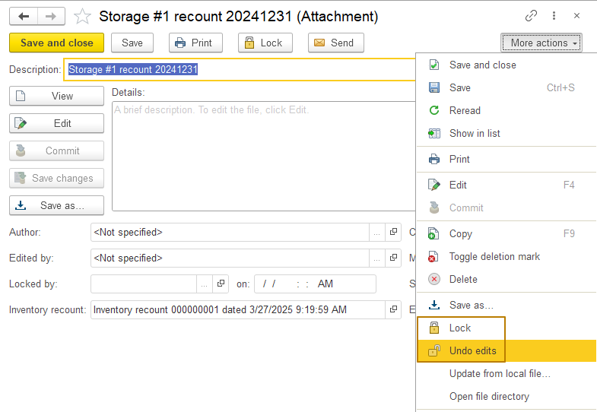
Let's get back to the presentation of attached files for the owner object. On my document form, attached files appear as a hyperlink to another form in the "Go to" section, so to attach a file to a document, I have to switch to the attachments form and then back, which is not very convenient. At the same time, we have already seen the form of the "SalesOrder" document at the beginning of this section, where the document form has a submenu with a paperclip icon for attaching files and a hyperlink "Attachments" next to this submenu. How can I make the same interface in the form of my document? Everything is very simple, as in the case of connecting an object to the print and attachable commands subsystems, you need to insert a call to certain procedures in the event handlers, and also insert attachable procedures in the form module.
First, you need to add a call to the FilesOperations.OnCreateAtServer procedure at the OnCreateAtServer event handler procedure, having specially prepared the data for transfer to the parameters of this procedure. If I need a hyperlink "Attachments" on the command bar, I have to call the function FilesOperations.FilesHyperlink(), fill the property of the resulting "Location" structure with the value with the name of the group where the hyperlink should be placed on the form, in my case it is the command bar of the form:
FilesHyperlink = FilesOperations.FilesHyperlink();
FilesHyperlink.Location = "CommandBar";
The full code in the OnCreateAtServer handler looks like this:
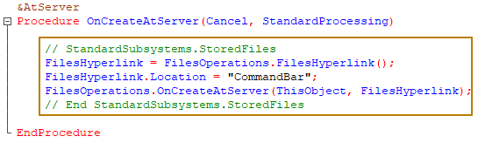
I check the document form in Enterprise mode and see that everything worked out:
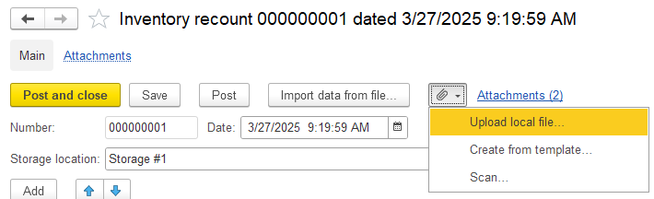
As you can see, the hyperlink view even contains the number of files attached to the object, which is convenient for the user. Now you can disable the "Attachments" hyperlink in the "Go to" section under the form header, to do this, you need to uncheck all the flags in the form's command interface section for the AttachedFiles command:
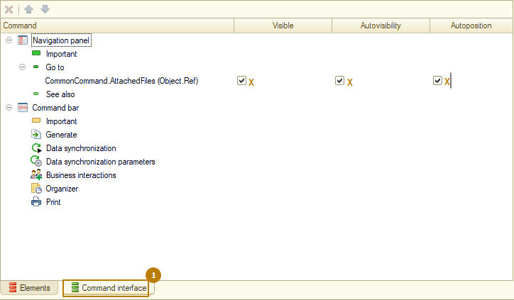
I check the appearance of the form and see that the hyperlink command at the "Go to" section is now invisible:
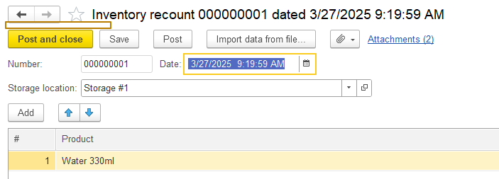
Now we need to insert other calls and handler procedures so that everything works correctly. In the OnOpen event handler, we need to call the procedure
FilesOperationsClient.OnOpen(ThisObject, Cancel);
in order to change the visibility of the scan button if scanning is unavailable (like in Web-client mode):
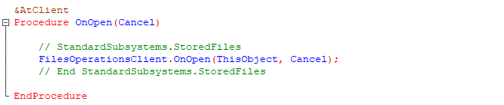
I also insert a call to the procedure
FilesOperations.OnWriteAtServer(Cancel, CurrentObject, WriteParameters, ThisObject);
in the OnWriteAtServer handler and a call to
FilesOperationsClient.NotificationProcessing(ThisObject, EventName);
in the NotificationProcessing handler. After that, it remains to add the attachable command handlers:
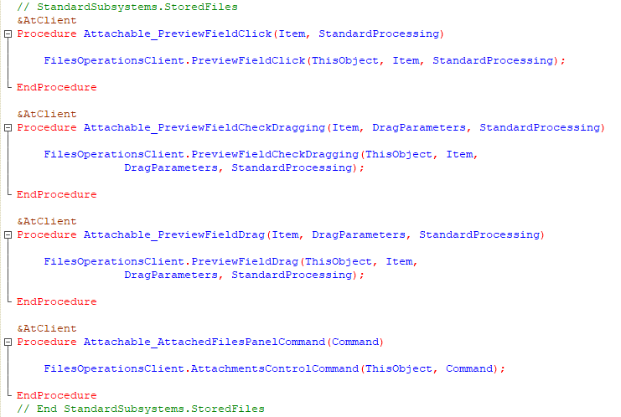
I took the code for these attachable command handlers from the "_DemoSalesOrder" document so as not to write it myself. In case you also copy the form event handlers, I remind you that in this case you also need to link the event to a handler from the form properties palette or from the list of procedures and functions of the form module so that the event has a handler specified. Otherwise, the OnOpen procedure (or handler procedure for another event) you inserted will not work as a handler when the OnOpen form event occurs:
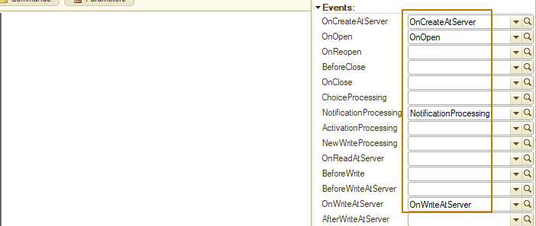
Module Markup
I have deliberately avoided the topic of module markup so as not to distract you from more important things, but now it is time to shed some light on this topic. Pay attention to how the code is organized in the "_DemoSalesOrder" document, in order to separate procedures and functions by type and meaning (form handlers are together, form element handlers too, etc.) module regions are used.
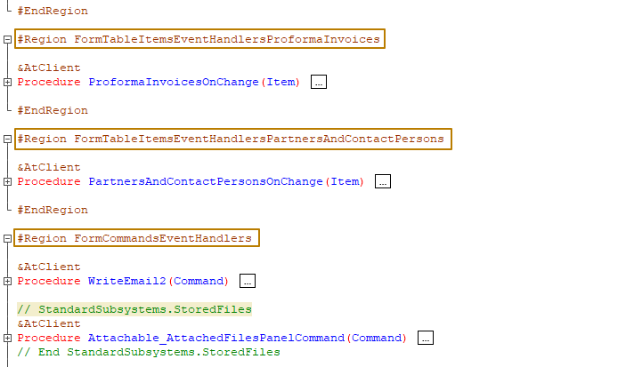
A Region can be easily created by writing
#Region <RegionName> (the region name is written without spaces)
// code inside the region
#EndRegion
Regions can be collapsed and expanded. Thus, the code in the module is always structured and the developer spends less time reading the code and always knows in which regions he should look for a particular procedure/function:
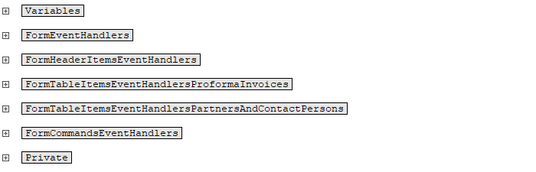
Note: By pressing the key combination Ctrl + Shift + Num- (the minus symbol on the Num keyboard) and Ctrl + Shift + Num+ (the plus symbol on the Num keyboard), you can collapse and expand all the "nodes" in the module. By the way, this also works in reports and in any other tree structures in 1C, for example, in a list of a hierarchical catalog, when the "Tree" view mode is selected in the list properties.
The recommended list of areas for each type of module is regulated by the 1C development standards so that the key regions are uniform in all products. Inside the top-level regions, you can create your own regions with any names (preferably ones that provide useful information to all developers). Regions can also be created inside procedures and functions, this can also be useful for highlighting a part of the code in a difficult-to-understand procedure/function.
Let me create regions in the form module of my document and distribute procedures and functions among them (you can use other standard objects as a guide, for example, for a document form, look at the structure of another document's form module):
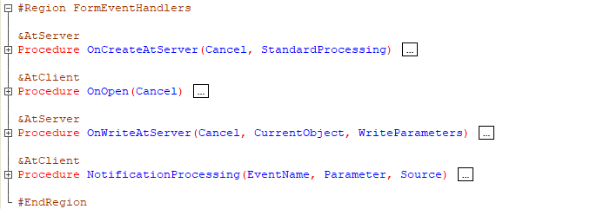
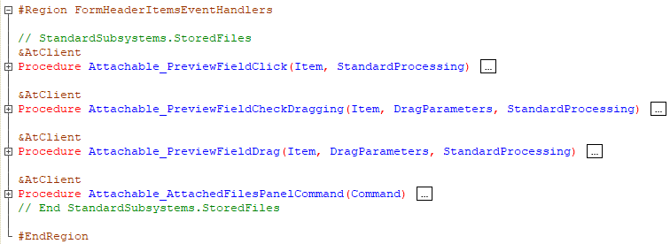
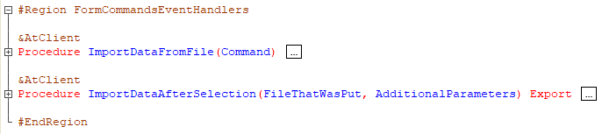
You must admit, it's much easier to navigate the module this way. I recommend that you use this approach, especially for modules with a lot of code.
Back to the task
Let's return to the FilesOperations subsystem and I see that all the buttons in the file submenu work, which means the document form revision is complete.
Now I would like to show you how to display a paperclip icon in the file owner object list form, which provides information that the object contains attached files. Here's how it looks in the list of documents _DemoSalesOrder:
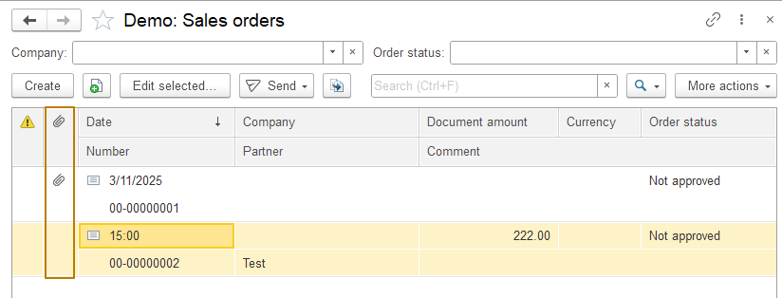
In order to display such an icon for documents that have an attachment, you need to make 2 changes:
- In the dynamic list’s query in the list form, you need to add the HasFiles field, in which the value takes 0 if the object does not have attached files, and 1 if there are attached files
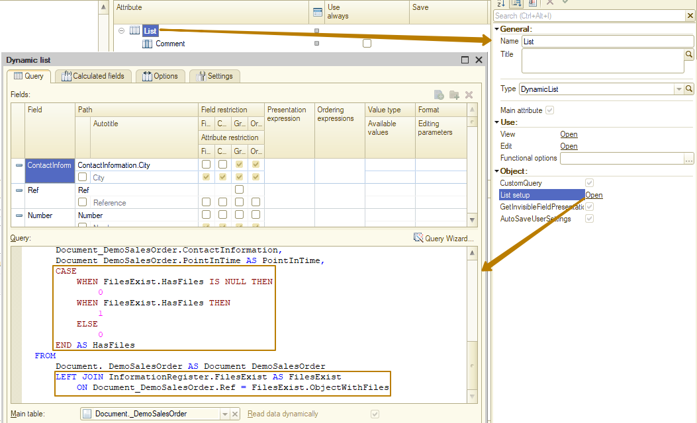
- Add this field to the form table, select the field type "Image field", disable the title and set the "ClipCollection" picture in the "ValuesPicture" property, consisting of two consecutive pictures - an empty picture (for the value 0) and a "paperclip" picture (for the value 1). In the "HeaderPicture" property, select the "Clip" picture
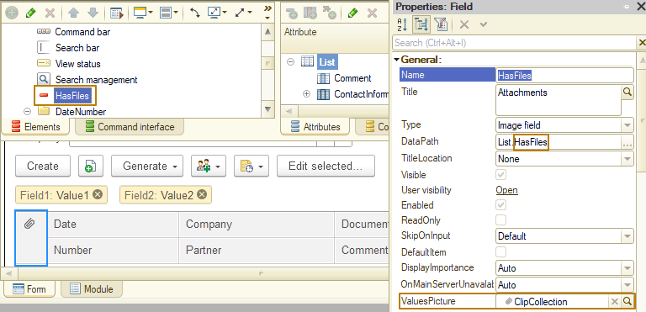
I create a list form for my document, enable the "CustomQuery" flag in the properties of the "List" dynamic list, open the list settings and add a join to the "FilesExist" information register in the query text, and then follow the instructions above.
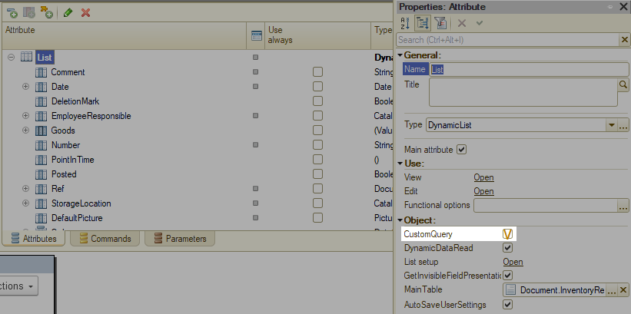
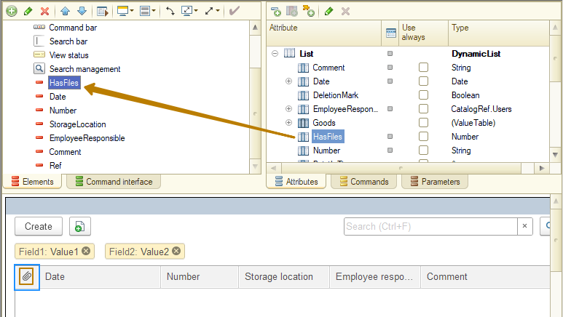
After that, I update the DB configuration and run the program to check. I see that for my only document, the paperclip image is displayed in the line, but to check whether it is displayed for any document, I create another "Inventory recount" document without attachments and return to the list form. Everything works correctly:
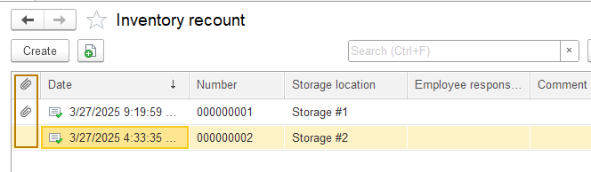
This completes the integration of the document with the FilesOperations subsystem. In fact, the subsystem contains a large number of various procedures and functions, but it is not possible to list and demonstrate them all in one lesson (and there is no point in doing so). I recommend that you find out about them by yourself one by one when you encounter tasks in which you need to perform some actions with attached files.
For example, when working programmatically with an object that may have attached files, it may be necessary to get all of its attached files. In this case, you can use the FillFilesAttachedToObject() procedure, to which you need to pass a reference to the file owner and an array to which references to the attached files will be added:
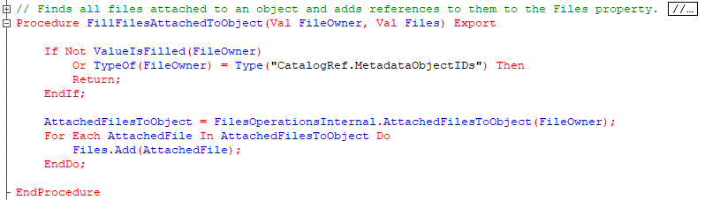
Perhaps the cornerstone of the subsystem is the FileData() function of the FilesOperations common module, which returns information about a file (meaning a link to a file catalog, not a file on disk) and is used everywhere when working with files of the information base.
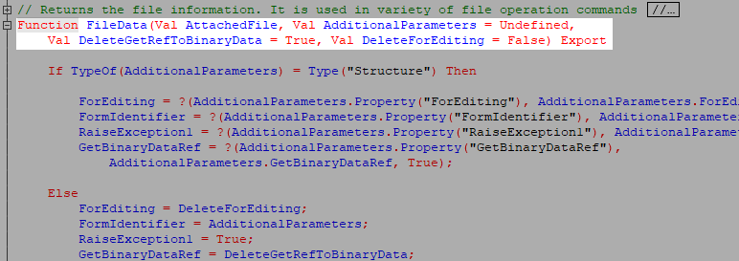
For example, the client procedures OpenFile(), OpenFileDirectory() and SaveFileAs() from the FilesOperationsClient common module, which work similarly to the client procedures from the FileSystemClient common module, accept as parameters not a link to a file, but a FileData structure:
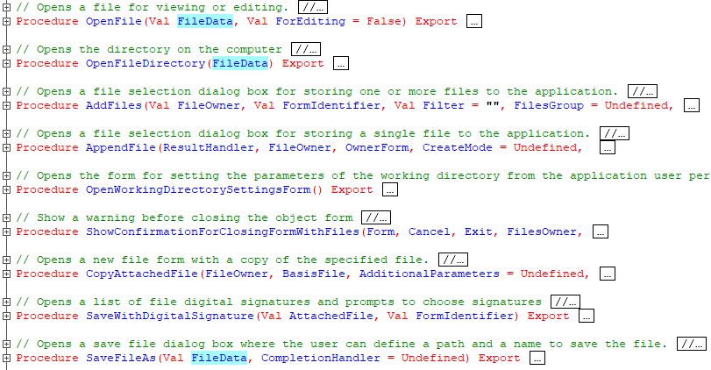
In the same server module, you can get binary data of a file, add a electronic signature to a file, save a file with an electronic signature, copy attached files from one owner object to another, and much more. Try to use several of those methods yourself.

